

Table of Contents

Motivation 3

Objectives 5

2.1. Brand Awareness 5

2.2. Customer Acquisition 5

2.3. Customer Retention 5

2.4. Customer Support 5

2.5. Sales And Revenue 5

List Of Resources 5

3.1. Homepage 6

3.2. About Us 8

3.3. Services 9

3.4. Connect With Us 9

3.5. Our Portfolio 9

3.5.1. Marketing: 9

3.5.2. Public Relations: 10

3.6. News & Insights 12

User Persona 13

Sitemap 14

Refinements and Improvement from Part 1 Feedback and Reflection 15

Reference List 19

***Part 1***

# Motivation

At CTRL Media, we recognize that a strong online presence is essential for brands looking to engage effectively with their audience. A well-curated website is the foundation of digital visibility, ensuring discoverability through search engines and digital channels. By eliminating geographic limitations, we help brands reach broader markets and attract new clients beyond their local scope. Our approach integrates interactive elements, compelling content, and seamless navigation to keep visitors engaged and encourage action. Acting as a central hub for information, our expertly crafted digital experiences build trust, credibility, and long-term customer relationships.

* Increasing Online Presence
* Reaching A Broader Audience
* Enhancing Customer Engagement
* Providing Information and Updates

##### Figure 1:



(Small Business Trends, 2024)

Before making a purchase, 82% of consumers do online research on goods or services. With 48% of respondents citing a website's design as the most important consideration when evaluating a company's legitimacy, a well-designed website increases brand visibility and credibility (Small Business Trends, 2024).

##### Figure 2:



(TechBullion, 2025)

The tech sector is nonetheless innovating quickly in spite of economic uncertainty. Deloitte projects that global IT investment would increase by 9.3% in 2025, with AI spending rising at a rate of 29% between 2024 and 2028. This expansion highlights how crucial successful PR tactics are becoming in the tech industry (TechBullion, 2025).

##### Figure 3:

[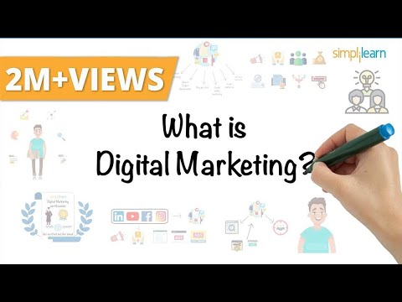](https://www.youtube.com/embed/bixR-KIJKYM?feature=oembed)

(Youtube, 2025)

##### Figure 4:

[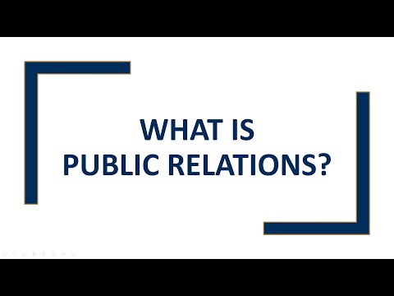](https://www.youtube.com/embed/VejDCJ9_wuk?feature=oembed)

(Youtube, 2025)

# Objectives

## 2.1. Brand Awareness

* Create a powerful online presence to increase visibility and trust by using SEO-optimized content, captivating images, and narrative.

## 2.2. Customer Acquisition

* Use smart calls to action, clear value propositions, and a flawless user experience to draw in and win over new customers.

## 2.3. Customer Retention

* Encourage enduring connections by providing clients with individualised experiences, case studies, and interesting information.

## 2.4. Customer Support

* Increase customer satisfaction and trust by offering easily available tools, frequently asked questions, and direct lines of connection.

## 2.5. Sales And Revenue

* Make the most of lead generation and conversion tactics to propel company expansion with focused service offers and compelling marketing.

# List Of Resources

## 3.1. Homepage

* ****(Different logo variations will be used, PS: play the animated logo… appears blank double click)









##### Figures 5-9: (Above)

* Slogan/ Strapline

Own Your Narrative

* Links to other pages (examples)
* ctrlmedia.com/About-Us.html
* ctrlmedia.com/Services.html
* ctrlmedia.com/Connect-With-Us.html
* ctrlmedia.com/Our-Potfolio.html
* ctrlmedia.com/News-And-Insights.html
* Brief overview of the company (the company direction, and overview of the other website link- click for more information for… about us, news and insights, etc.)

* Year & trademark (example; 2025, ®, ©, ™ , Ts & Cs, etc.)

## 3.2. About Us

At CTRL Media, we are a dynamic public relations and marketing firm dedicated to advancing companies via strategic narrative, digital innovation, and effective communication. Our team of PR experts, digital strategists, and creative masterminds collaborates to develop impactful campaigns that boost interaction, build credibility, and yield measurable results.  
  
With our expertise in digital marketing, public relations, brand development, content creation, social media management, and event marketing, we offer a comprehensive approach to brand expansion. We combine data-driven insights with creative quality to ensure our clients stand out in a rapidly evolving sector.  
  
  
Whether you're an established business looking to expand or a start-up attempting to make an impression, CTRL Media is your dependable partner in building a strong, identifiable brand. To take control of your brand's success, contact us right now! OWN YOUR NARRATIVE.

##### Figure 10:



## 3.3. Services

* Marketing:
* Branding and Strategy
* Digital Marketing
* Content Marketing
* Advertising and Media Buying
* Market Research and Consumer Insights
* Event Marketing
* Public Relations (PR):
* Media Relations
* Crisis Communication
* Reputation Management
* Thought Leadership and executive Positioning
* Community and Influencer Relations
* Corporate Communications

## 3.4. Connect With Us

* Social Media Pages (Instagram, Facebook, X, TikTok, etc.)
* Email
* Customer Support/ Chatbot
* Telephone Number
* Web Contact Forms
* Newsletter Subscriptions
* Consultation Request

## 3.5. Our Portfolio

* This section of the webpage will be filled with the brand’s previous work as proof for their expertise as company in the field of work.

### 3.5.1. Marketing:

##### Figure 11:



(Nike, 2025)

Nike has used humour, current social trends, and a unique brand personality to great effect in its social media marketing. The brand has maintained its cultural relevance thanks to this strategy, which has produced a sizable following and excellent engagement across platforms (Brafton, 2025).

##### Figure 12:

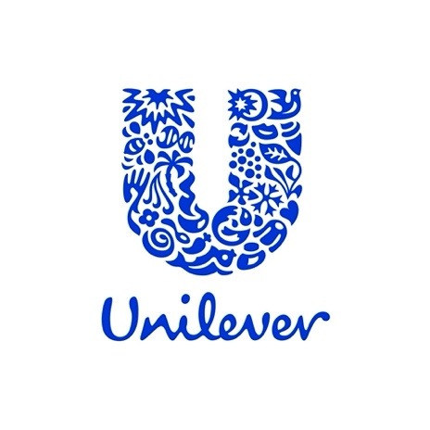

(Unilever Pakistan, 2025)

Unilever dramatically raised its investment for influencer marketing, moving away from conventional advertising techniques. In line with trends demonstrating the efficacy of real and targeted content, Unilever successfully advertised its products by working with influencers who have gained the trust of their audience (The Times, 2025).

##### Figure 13:



(Pinterest, 2025)

Burberry adopted the escapist trend in marketing in 2025 by incorporating surreal elements into their advertising campaigns. Customers looking for fantastical and surreal encounters found resonance with this strategy, which resulted in high levels of engagement (Vogue Business, 2025).

### 3.5.2. Public Relations:

##### Figure 14:



(Vita Coco, 2025)

On Valentine's Day in February 2025, Vita Coco changed their PR approach by erecting a do-it-yourself vending machine in Washington Square Park in New York. Free Strawberries & Crème desserts produced with Vita Coco's coconut water were distributed to onlookers as part of this community-focused strategy, creating real relationships and natural buzz (The Sun, 2025).

##### Figure 15:

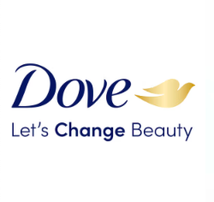

(Unilever, 2025)

In keeping with its dedication to real beauty standards, Dove started the #TheSelfieTalk campaign. Through a reverse picture editing technique that produced natural, unfiltered images, this project addressed the impact of social media on girls' self-esteem. Audiences responded favourably to the campaign, which reaffirmed Dove's commitment to genuine beauty (Zen Media, 2023).

##### Figure 16:



(Lego, 2025)

Customers were asked to submit images of their creations as part of Lego's "Rebuild the World" campaign, and the images were subsequently shown on the company's website as a 3D globe. Users all across the world were engaged by this playful and participatory strategy, which complemented Lego's brand identity and improved community relations (Zen Media, 2023).

## 3.6. News & Insights

* Case Studies
* Company Updates
* Industry News & Trends
* Expert Opinions & Thought Leadership
* Writing and Marketing Tips
* Book & Media Reviews

# User Persona



# Sitemap



***Part 2***

# Refinements and Improvement from Part 1 Feedback and Reflection

##### Figure 17:



(Pohotona, 2025)

##### Figure 18:



(Pohotona, 2025)

##### Figure 19:

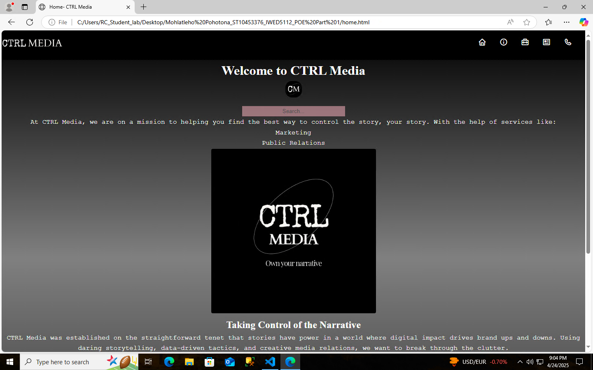

(Pohotona, 2025)

##### Figure 20:

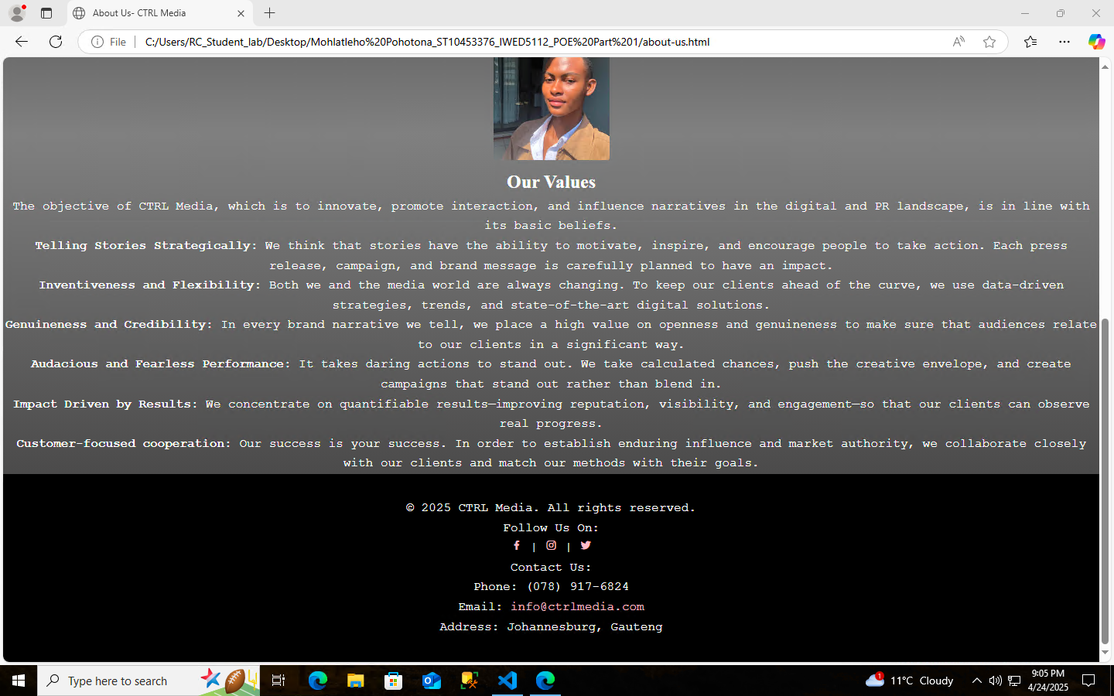

(Pohotona, 2025)

##### Figure 21:

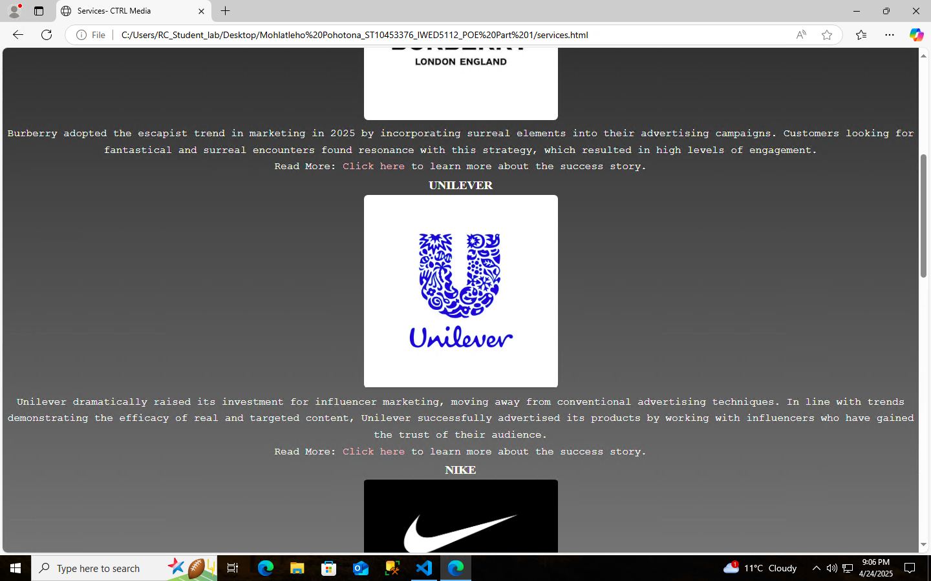

(Pohotona, 2025)

##### Figure 22:

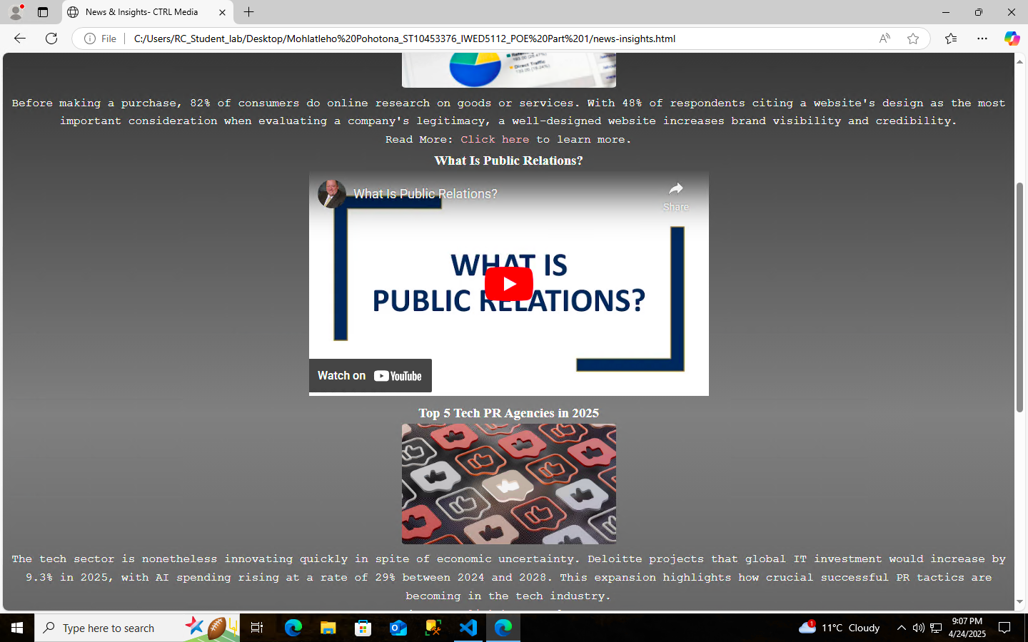

(Pohotona, 2025)

##### Figure 23:

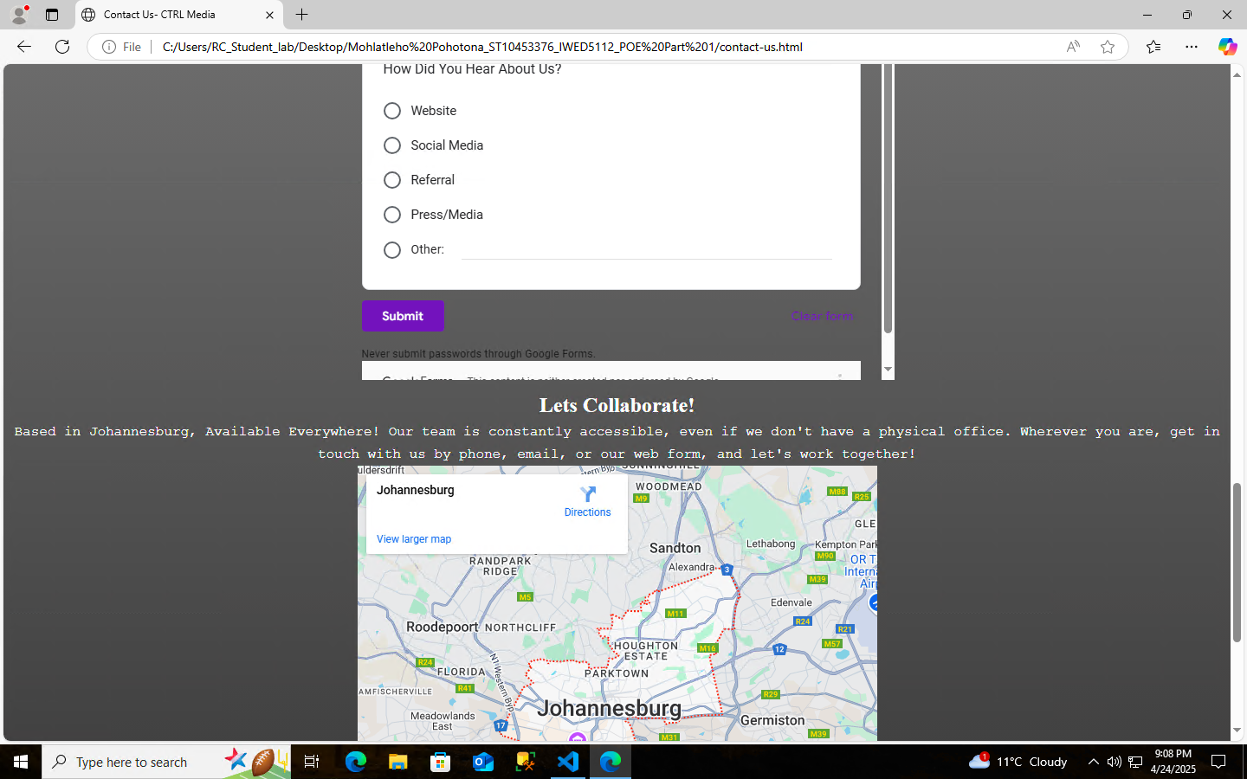

(Pohotona, 2025)

In this part of the POE, I explored design elements using CSS and applied them thoroughly to my website:

The CSS file I created is linked on every HTML page that is on my website, the common changes consist of logo image in the header being different from Part 1’s version- it’s a display on the name using a different logo variation… which was tailored to fit the header in a thinner way rather than a thick one. On the right side of the header is the navigation bar which now only consists of icons that redirect the user to other HTML pages. When hovering over the icon a shade of pink highlights your desired web page destination. Moving from the header into the body of the website- all texts and images (embedded content as well) have been centred to fit the style of the brand and how the layout sits. Additions are a search bar and logo variation that is a stamp for the brand. Links are highlighted in pink. The choice to add the colour pink was to make the website more visually appealing as opposed to simply having it black and white. All images have been adjusted to a border radius to avoid harsh/sharp corners. The video on the homepage has been placed into auto-play and controls are inaccessible. Fonts have been used match the brand’s image- typewriter and cardo. The content in the footer is centred, and icons are placed in the place of social media links as well emails.

# Reference List

**Brafton,** 2025. Companies with good marketing strategies. [online] Available at: <<https://www.brafton.com/blog/content-marketing/companies-with-good-marketing/>> [Accessed 19 March 2025].

**LEGO,** 2024. Official LEGO website. [online] Available at: <<https://www.lego.com/en-za>> [Accessed 19 March 2025].

**Nike,** 2024. Nike Inc. Logos. [online] Available at: <<https://about.nike.com/en/newsroom/collections/nike-inc-logos>> [Accessed 19 March 2025].

**Pinterest,** 2024. Burberry logo design. [online] Available at: <<https://za.pinterest.com/pin/996632592520854197/>> [Accessed 19 March 2025].

Pohotona, M.S., 2025. *Images Depicting Website Development.* [photograph] (Personal Collection). Unpublished.

**Small Business Trends,** 2023. Website Statistics: The Impact of Online Presence on Businesses. [online] Available at: <<https://smallbiztrends.com/website-statistics/>> [Accessed 19 March 2025].

TechBullion, 2025. Top 5 Tech PR Agencies in 2025. [online] Available at: < <https://techbullion.com/top-5-tech-pr-agencies-in-2025/>> [Accessed 20 March 2025].

**The Sun,** 2025. Vita Coco shifts PR strategy with community-centered pop-up. [online] Available at: <<https://www.the-sun.com/shopping/13576140/vita-coco-shifts-pr-strategy-community-centered-popup/>> [Accessed 19 March 2025].

**The Times,** 2025. The voices that matter: Unilever recruits an army of influencers. [online] Available at: <<https://www.thetimes.co.uk/article/influencers-unilever-recruits-voices-that-matter-rbkrhxfx8/>> [Accessed 19 March 2025].

**Unilever**, 2024. Dove brand overview. [online] Available at: <<https://www.unilever.com/brands/beauty-wellbeing/dove/>>[Accessed 19 March 2025].

**Unilever Pakistan**, 2024. The Unilever logo. [online] Available at: <<https://www.unilever.pk/our-company/the-logo/>> [Accessed 19 March 2025].

**Vita Coco**, 2024. Logos. [online] Available at: <<https://vitacoco.com/blogs/multimedia/tagged/logos>> [Accessed 19 March 2025].

**Vogue Business**, 2025. Why escapism is the new marketing currency. [online] Available at: <<https://www.voguebusiness.com/story/fashion/why-escapism-is-the-new-marketing-currency>> [Accessed 19 March 2025].

**Zen Media**, 2025. 9 Successful PR Campaigns. [online] Available at: <<https://zenmedia.com/blog/9-successful-pr-campaigns/>> [Accessed 19 March 2025].